**Question no 4**

**Part A**

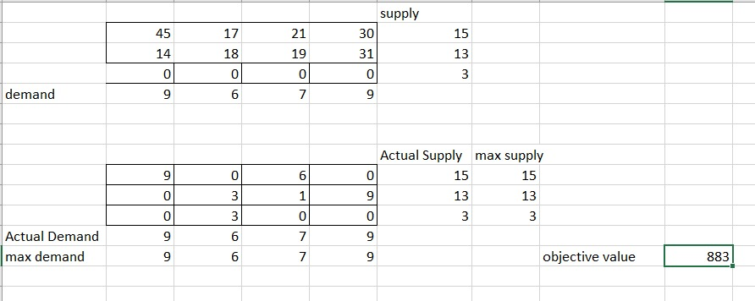

**Excel Solver**

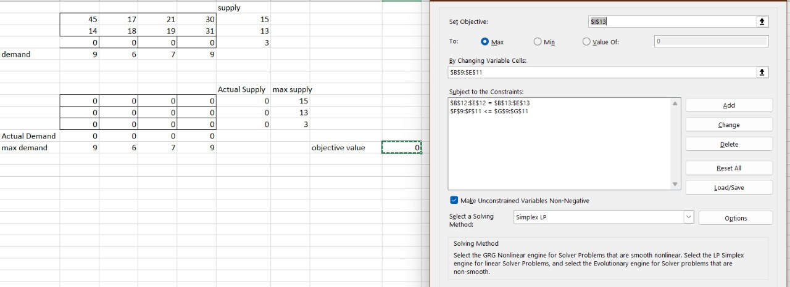

**Question no 4**

**Part B**

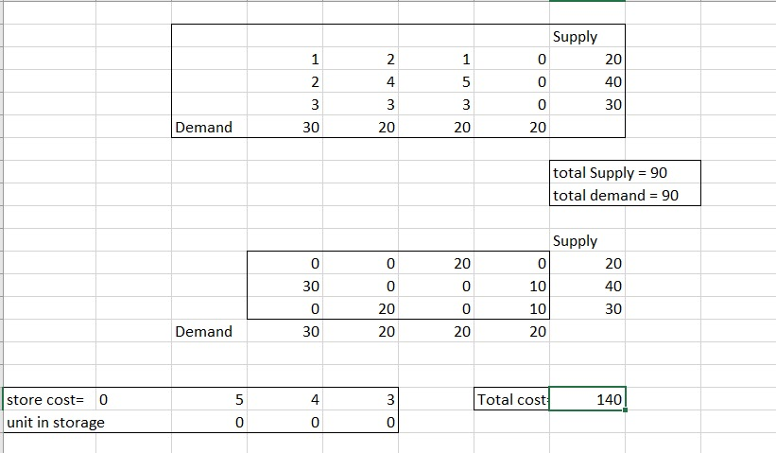

**Excel Solver**

**Excel Solver**



